Agent Based Model of Land Use Change in Sriperumbudur Taluk
Abstract

We built an agent-based model that looked at land use change in a Peri-Urban scenario. The idea was to understand how agricultural land use patterns changed in response to inflationary pressures, and push-pull factors due to the presence of industry nearby. We found some very interesting emergent patterns where farmers sold their land, and left the area and changed occupations. This was in turn corroborated by anecdotal evidence from the field.
Introduction to Agent Based Models

An Agent-Based Model is a computational model which simulates the actions of, and interactions between discrete autonomous agents. This is done in order to assess their effect on the system as a whole. These agents have specified attributes and behaviours and could be individuals such as people, cars etc.
These agents create patterns in time and space that could not have been foreseen earlier. This is due to the concept of emergence.

When a system as a whole displays a particular pattern which is not immediately obvious from the rules at a micro level, the behaviour is described as emergent.
This overall behaviour is by definition not explicitly nor implicitly built into the model. By contrast, conventional top-down modelling techniques (eg Dynamic General Equilibrium models) assume macroscopic behavior by definition. The bottom-up, agent-based approach does not make these sorts of assumptions and hence the model can give greater insight into causality!
Agent Based Models and Land Use Change
Human decision making plays an important role in land use change. There is also a growing agreement that linkages across local and regional scales are important, as are interactions between regional and local drivers of land use change. As these form a complex system, Agent Based simulations are thus useful to study the consequences of these human-environment interactions.

Methodology

Using the NETLOGO programming language, we defined three kinds of agents: farmers, workers and “farkers” (farmers who become workers). They are randomly allotted patches of land within the given decision space. We then in turn randomly allocated different fertility values to each patch of land. At the centre of the space was the SIPCOT area, and the price of the land also varied by its proximity to SIPCOT.
Each agent had an “income”, “expenditure” and “saving” attribute. The income of a farmer was directly proportionate to the fertility value of the land he currently had, while the income of a worker was inversely proportional to his distance from SIPCOT.
At every iteration, the agents faced 2 binary, and 1 open-ended choice. First to sell or not to sell, then second, the location to which to move, then third, whether to stay on as a farmer or not. We assumed each agent wanted to maximize possible income given current income, occupation, land price and so on and would make choices accordingly.
A farmer could choose to change his occupation and become a worker if a worker in his current position would earn more than he did. At any point in time, if after selling his current plot of land, an agent had enough savings to purchase land elsewhere, he would do so.
Findings
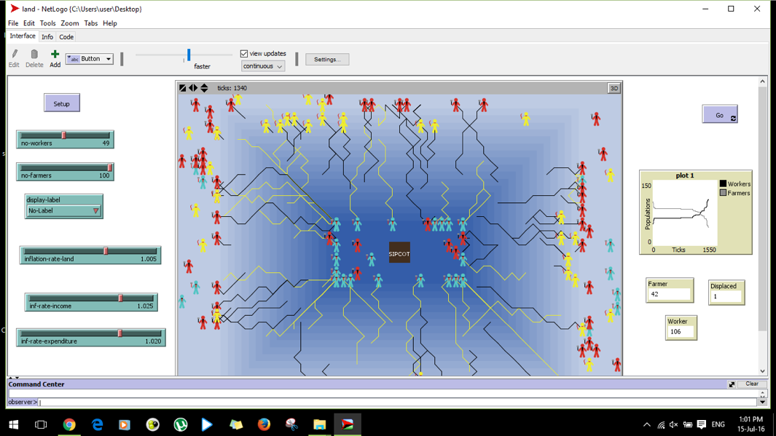Model Output Display shows how workers cluster while who sell off their land are relegated to the margins and change their occupation

With NETLOGO, we can adjust various growth rates, such as those of Land price, income, and expenditure. Using those, we found some interesting trends:
When we ran the model with the rate of land price growth as almost equal to the rate of income growth, the workers or the farmers did not move either away or towards SIPCOT.
However when we set the rate of land price growth as greater than the rate of income growth, it made more sense for the workers or the farmers to sell their land at a premium and move away from SIPCOT.
We found another interesting emergent phenomenon, where, when the savings of a farmer went below the value of the land they were currently on (due to low income as land was not viable for farming) he either became a worker or he moved away from SIPCOT.
However, when the growth rate of land in land prices is less than the growth rate of income, the workers tended to move towards SIPCOT (as they could afford to). But farmers would move towards SIPCOT only if their income increased dramatically.
In the long run we found that farmers who lived near SIPCOT sold off their land, and went to live “on the margins”, and in many cases changed their occupations as now farming became no longer viable. Even then they could not move back towards SIPCOT now, as the distance from SIPCOT condemned them to low incomes, and the price of land near SIPCOT was too high for them to be able to move closer. Workers in turn ended up clustering near SIPCOT.
The way forward – New directions for research
When we make things more complicated, and introduce new variables, parameters and decision vectors, we face big challenges in using agent based modeling!
The agents in this case acted as simple utility-maximisers.
The mathematics that Agent Based Models normally use to simulate the behaviour of the agents does not account for the way people really make decisions in ambiguous, information-poor environments, or when faced with existential threats such as environmental damage and climate change.
We need to use insights from Behavioural science such as heuristics, biases, judgement errors and concepts such as Daniel Kahneman’s Prospect Theory and Herbert Simon’s Satisficing concept to account for this diminished rationality.
This was a relatively simple and generalizable model. It was also theoretical in the sense that it could be applied to a lot of industrial-agricultural land use change scenarios.
One way to make this model more specific would be to integrate GIS data about Sriperumbudur/SIPCOT in particular and see whether the findings of our model can account for historical changes in land use patterns

